STIMULUS

HANDOUT FOR

CAP QUESTIONS

2023

MOCK MCQ

EXAM

NB: one or two of the tables or figures are

not as sharp as would be ideal - best we

could do with the source material.

Opening the Stimulus pdf in a browser

(R-click and choose from 'open with')

rather than in Adobe reader improves the

clarity and still allows you to rotate the page to

view any landscape-oriented tables or figures

as necessary.

If printing, print from the Word docx version.

CAP Question 1 (20 marks)

“Skills for pills”: The dialectical-behavioural therapy skills training reduces polypharmacy in borderline personality disorder

Joaquim Soler, Elisabet Casellas-Pujol, et al, Acta Psychiatrica Scandinavica, Jan 2022

*Abstract*

*Objective:* Polypharmacy and overprescription of off-label medications are common in patients with borderline personality disorder (BPD). The aim of the present naturalistic study was to explore whether the skills training module of dialectical-behavioural therapy (DBT) can reduce polypharmacy in these patients in routine clinical practice.

*Methods:* Retrospective, observational study of 377 patients with a primary diagnosis of BPD consecutively admitted to the BPD outpatient unit from 2010 through 2020. All patients were invited to participate in the DBT skills training module (DBT-ST). DBT-ST participants (n = 182) were compared with a control group who did not participate in DBT-ST (n = 195). Pre-post intervention changes in medication load and use of antidepressants, benzodiazepines, mood stabilizers, and antipsychotics were evaluated.

*Results:* At baseline, most patients (84.4%) were taking at least one medication and 46.9% were on polypharmacy. Compared to controls, patients in the DBT-ST group presented a significant reduction in the number of medications (2.67–1.95 vs. 2.16–2.19; p < 0.001), medication load (4.25–3.05 vs. 3.45–3.48; p < 0.001), use of benzodiazepines (54.4%–27.5% vs. 40%–40.5%; p < 0.001), mood stabilizers (43.4%–33% vs. 36.4%–39.5%; p < 0.001), and antipsychotics (36.3%–29.1% vs. 34.4%–36.9%; p < 0.001).

*Conclusions:* These findings suggest that patients with BPD can benefit from the DBT-ST module, which may reduce the medication load, particularly of sedatives. The results suggest that DBT-ST may be useful to treat overmedication in patients with BPD and could help to promote “deprescription” in clinical practice.

(Excerpt from Material and Methods:)

Data were retrospectively collected from 377 patients diagnosed with BPD and admitted to the outpatient BPD unit at the Department of Psychiatry at the *Hospital de la Santa Creu i Sant Pau*… Compared with general mental health center, the BPD Unit offers: reliable confirmation of BPD diagnosis with validated instruments, greater accessibility to the unit, emergency attention in crisis, higher frequency and duration of visits, therapeutic team with specific experience and sensitivity for BPD, family care, psychoeducation of disorder, general management and non- harmful strategies, and, finally, supervision of pharmacological treatment avoiding the excessive use of medication.

(Excerpt from Materials and Methods)

The DIB-R is an instrument designed to diagnose BPD and to assess the severity of the disorder within the last 2 years. The Spanish version has demonstrated good internal consistency (Cronbach's alpha, 0.89; sensitivity, 0.81; and specificity, 0.94).

(Excerpt from Psychotherapeutic intervention – Control group:)

Although these individuals did not receive any specific psychotherapeutic intervention for BPD compared with general mental health services, they valued the higher frequency of psychiatric visits, attention in crisis, family care, and greater experience and sensitivity in the management of BPD. These follow- up visits also include supervision of pharmacological treatment avoiding, if possible, the excessive use of medications, as recommended by all clinical guidelines. They also received non- harmful strategies based on the *Handbook of Good Psychiatric Management for Borderline Personality Disorder*.

Table 1

Figure 1

Differences between groups in prescription changes pre-post intervention:

Figure 2

Pre-post intervention differences in the prescription of antidepressants, benzodiazepines, mood stabilizers,

and antipsychotics:

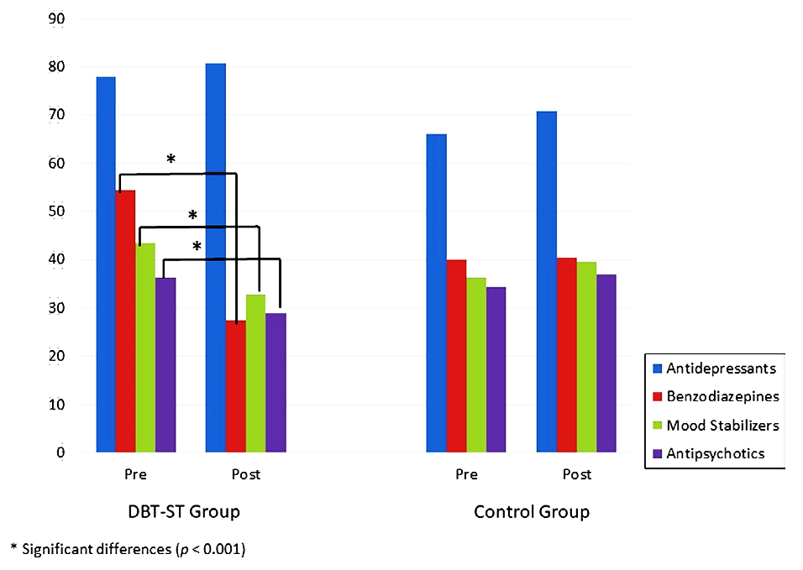

CAP Question 2 (20 marks)

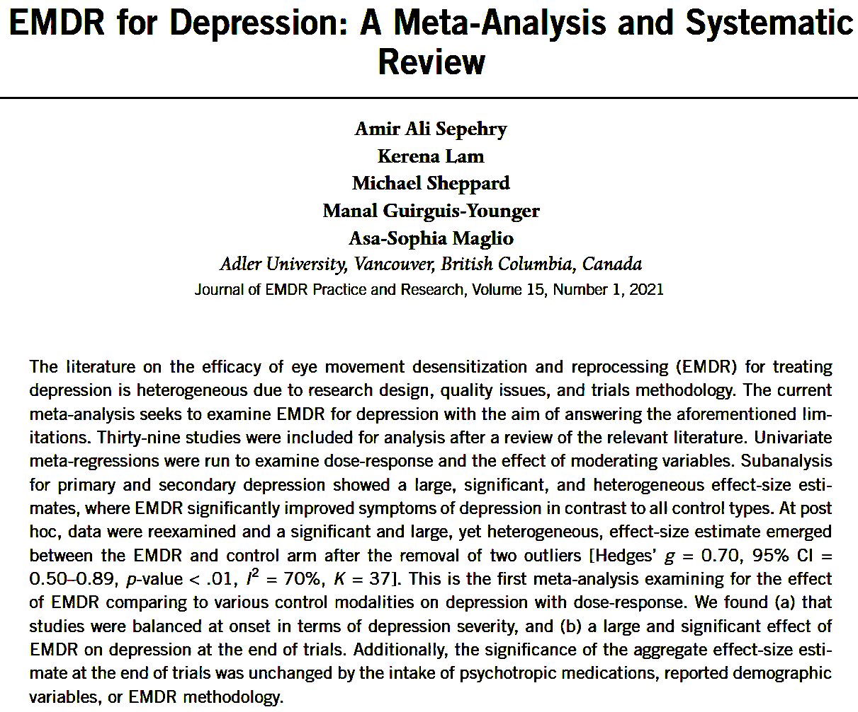

(excerpt from Method)

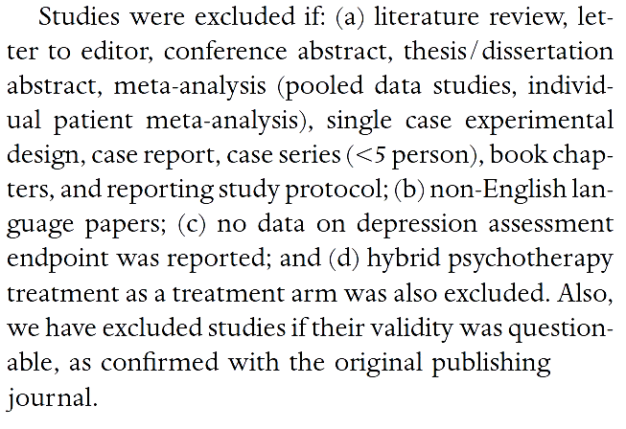

CAP Question 2 contd. PRISMA Flow Diagram showing study selection for meta-analysis on EMDR for

depression literature:

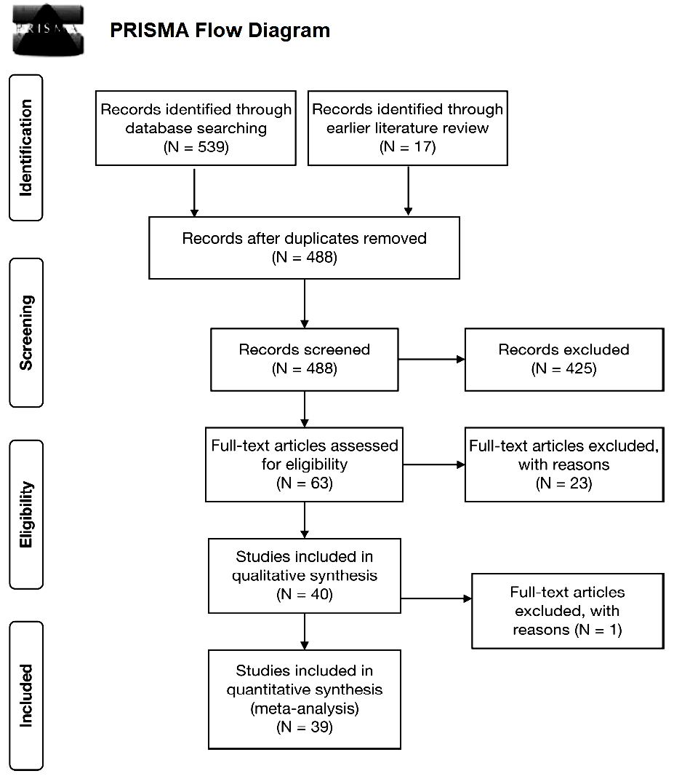

The kappa rate of agreement beween study coders (AAS and KL) was 88%, and in the event of a discrepancy, the conflict was resolved by discussion between the coders.

For all data analysis, we set the alpha level to .05 and used the Comprehensive

Meta-Analysis software (Ver 2.0) (Borenstein et al, 2005).

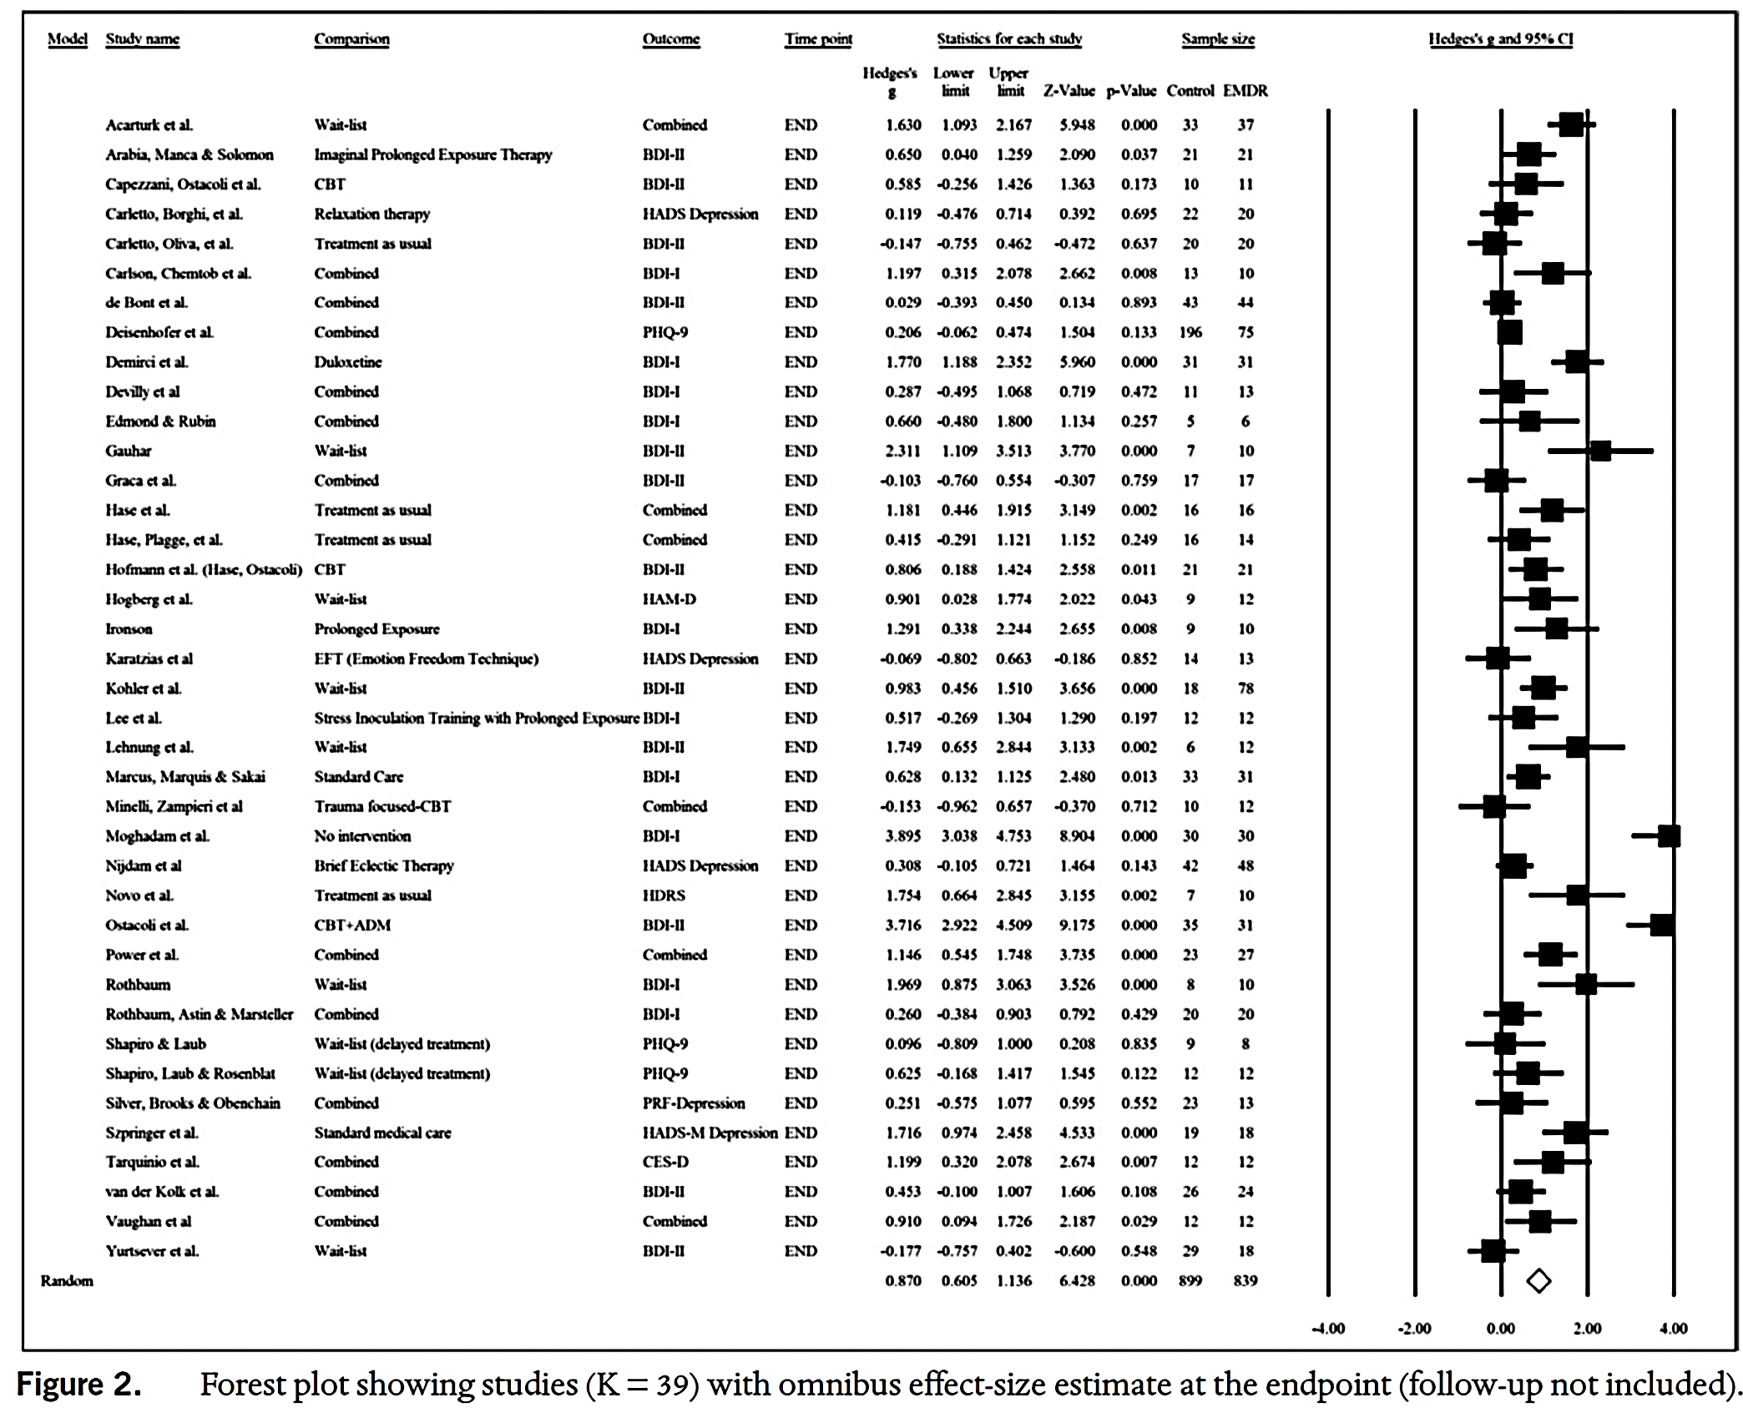

(excerpt from Results of Data Analysis)

When reviewing for heterogeneity, we removed the studies by Ostacoli et al. (2018) and Moghadam et al. (2015)

(excerpt from Limitations)

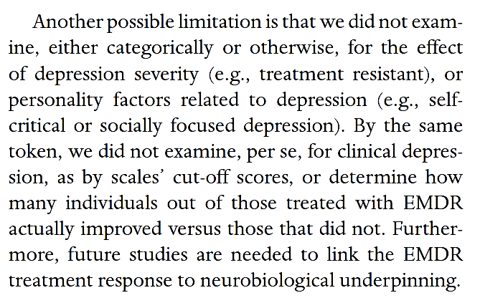

End of Stimulus handout