

THE ROYAL AUSTRALIAN AND NEW ZEALAND COLLEGE OF PSYCHIATRISTS

MOCK WRITTENS

MCQ PAPER 2016

(Produced by the New Zealand Training Programmes)

|  |  |
| --- | --- |
| Candidate’s name: | Date: |

*The real MCQ paper is these days done via a computer interface at special testing venues. This Mock Paper cannot replicate those conditions, but is still a useful exercise in managing the size of the task, the timing, and individual question types.*

*We suggest that candidates replicate actual exam conditions as far as possible, according to the rules in the* [*Exams section of the 2012 Regulations*](https://www.ranzcp.org/Files/PreFellowship/2012-Fellowship-Program/RPP-EXAMINATIONS.aspx) *(see: Written Examination policy esp. pages 7-12), and that they use the* [*MCQ Information*](https://www.ranzcp.org/Files/PreFellowship/2012-Fellowship-Program/Exam-Centre/MCQ-Exam-Information-V3-0.aspx)*,* [*tutorial MCQ exam*](http://www.pearsonvue.com/ranzcp/tutorial.asp)*,* [*and tutorial model answers*](http://www.ranzcp.org/Files/PreFellowship/2012-Fellowship-Program/Practice-Exam-Answers.aspx) *provided by the College to familiarise themselves with the MCQ electronic interface.*

*Note that this version of the MCQ can be completed electronically, on a computer using Word to fill in the correct answers in each answer box. Set your keyboard to caps lock to simplify this. Remember to do control-S to save your completed paper intermittently, and at the very end of the exam.*

*Allow yourself 3 hours and 10 minutes total time to complete the paper.*



THE ROYAL AUSTRALIAN AND NEW ZEALAND COLLEGE OF PSYCHIATRISTS

MCQ PAPER 2016

EXTENDED MATCHING QUESTIONS

|  |  |  |  |
| --- | --- | --- | --- |
| INSTRUCTIONS FOR ANSWERING THIS PAPER:  As you will mark it yourself we have done away with the “scantron” computer mark sheet. Answering each question at the place where the question is written is more like the on-line system and will make the marking process easier.   1. Follow the instructions on the previous page to do it electronically in Word.   Or, B) if doing it as a paper version after printing it off:   * **Use pencil so you can change it easily if need be.** * **Put your chosen answer letter in the box beside the question.** * **If you mess it up or make it hard to read, the only one confused will be you.**   Example: | | | |
| 50. | Weakness and fine tremor. |  |
| 51. | A generalised rash. |  |

Extended Matching Questions

Do not answer questions in this booklet. Use the separate answer sheet and pencil provided.

#### Each question is worth 1 mark

|  |  |  |
| --- | --- | --- |
|  | Amphetamine use |  |
|  | Anaemia of chronic disease |  |
|  | Cushing’s Disease |  |
|  | Epstein Barr virus |  |
|  | HIV |  |
|  | Huntington’s Disease |  |
|  | Hyperparathyroidism |  |
|  | Hyperthyroidism |  |
|  | Hypothyroidism |  |
|  | Interferon treatment |  |
|  | Lyme Disease |  |
|  | Prednisone use |  |

Which of the above is the MOST likely to be demonstrated by each of the following examples?

Please select only ONE option, BUT ANY OPTION MAY BE USED MORE THAN ONCE, IF REQUIRED.

|  |  |  |
| --- | --- | --- |
|  | Jason, a university student aged 20, presents with low mood, fatigue and sore throat |  |
|  | Frannie, a 50 year old woman, presents with difficulty sleeping, anxiety and weight loss. |  |
|  | Gary, A 67 year old smoker with recent admission for exacerbation of COPD, presents with irritability, decreased sleep and overactive thinking. |  |
|  | Kim, a 45 year old ex-intravenous drug user, presents with abnormal liver function tests, low mood and symptoms of depression. Increased irritability is also reported. |  |
|  | Natasha, a 30 year old woman, presents with low mood and functional changes of depression. There is a family history of her father and paternal grandmother presenting with abnormal movements before dying early. |  |

Extended Matching Questions

Do not answer questions in this booklet. Use the separate answer sheet and pencil provided.

#### Each question is worth 1 mark

|  |  |  |  |
| --- | --- | --- | --- |
|  | Amitriptyline | |  |
|  | Aripiprazole |
|  | Citalopram |
|  | Clonidine | |  |
|  | Concerta |
|  | Fluoxetine |
|  | Methylphenidate SR | |  |
|  | Risperidone | |  |

Which medication listed above is the MOST appropriate choice for each of the following examples.

Please select only ONE option, BUT ANY OPTION MAY BE USED MORE THAN ONCE, IF REQUIRED.

|  |  |  |
| --- | --- | --- |
|  | Has evidence as an antidepressant in adults but is considered likely to be harmful in children and adolescents. |  |
|  | Has reasonable evidence for managing irritability in young people with autistic spectrum disorder. |  |
|  | A good choice for once-daily dosing of a 14 year old with ADHD. |  |

Extended Matching Questions

Do not answer questions in this booklet. Use the separate answer sheet and pencil provided.

#### Each question is worth 1 mark

|  |  |  |
| --- | --- | --- |
|  | Catatonia |  |
|  | Clang Associations |  |
|  | Congruent Affect |  |
|  | Delusion of Guilt |  |
|  | Delusion of Poverty |  |
|  | Incongruent Affect |  |
|  | Motor Agitation |  |
|  | Motor Retardation |  |
|  | Neologism |  |
|  | Nihilistic Delusion |  |
|  | Poverty of Thought |  |
|  | Waxy Flexibility |  |
|  | Word Salad |  |

Which aspect of speech or behaviour listed above is MOST likely to be demonstrated by each of the following.

Please select only ONE option, BUT ANY OPTION MAY BE USED MORE THAN ONCE, IF REQUIRED.

|  |  |  |
| --- | --- | --- |
|  | Miriam, a 50 year old woman, is focused on all her belongings being taken from her. |  |
|  | During an interview, Anton, aged 24, says “I found it in my car, a guitar, near a star”. |  |
|  | Martin maintains his arm in the position it is placed for an extended period of time. |  |
|  | Helen presents as slow in her movements. |  |
|  | Kevin laughs when speaking of the death of his child. |  |

Extended Matching Questions

Do not answer questions in this booklet. Use the separate answer sheet and pencil provided.

#### Each question is worth 1 mark

|  |  |  |  |
| --- | --- | --- | --- |
|  | Behavioural reinforcement schedule |  |  |
|  | Cognitive Behavioural Therapy (CBT) or CBT for Eating Disorders (CBT-e) |  |  |
|  | Family Based Treatment |  |  |
|  | Inpatient admission for medical stabilisation and to prevent refeeding syndrome |  |  |
|  | Inpatient admission for refeeding until normal nutrition and at least 80% of target BMI |  |  |
|  | Interpersonal Therapy |  |  |
|  | Mentalisation Therapy |  |  |
|  | Play Therapy |  |  |
|  | Psychodynamic Psychotherapy |  |  |
|  | Specialist Supportive Clinical Management |  |  |
|  | Structural Family Therapy |  |  |

Which intervention listed above is the MOST appropriate choice for each of the following examples.

Please select only ONE option, BUT ANY OPTION MAY BE USED MORE THAN ONCE, IF REQUIRED.

|  |  |  |
| --- | --- | --- |
|  | Nick, a 19 year old young man, a competitive rower, has just finished high school and lives at home with his parents and younger siblings. He presents with a 4 month history of anorexia nervosa, characterised by nutritional restriction relative to extreme exercise, but is still eating with prompting from his parents. He admits to some dizziness during exercise. His BMI is 15, his pulse 50 bpm (lying,) 60 bpm standing and BP is 90/60 with minimal postural change. |  |
|  | Sophie, aged 20, who is on a weight reduction diet, has lost 18 kg over the last 10 weeks. She has stopped eating altogether in the last week, subsisting on black unsweetened coffee and water. Her BMI is 24, pulse 55 bpm lying, 80 bpm standing. BP is 95/60 with minimal postural drop. She feels dizzy intermittently and has fainted twice. |  |
|  | Marama, a 28 year old gym instructor and personal trainer, has a 12 year history of feeling out of control and rapidly eating large amounts of fatty and sweet foods. These episodes occur in the evenings 3 or 4 times a week. The following morning she drinks only protein shakes until dinner and does an extra morning workout. She generally eats “healthy foods’, which are low in carbohydrates and fats. She denies purging, using laxatives or diet pills. She denies physical symptoms, her BMI is 20, her pulse is 55 bpm and BP 100/60 - both with no postural change. |  |
|  | Louise, a 38 year old woman with a long history of anorexia, has had several lengthy inpatient admissions in the past. Her current BMI is 14. |  |

Extended Matching Questions

Do not answer questions in this booklet. Use the separate answer sheet and pencil provided.

#### Each question is worth 1 mark

|  |  |  |
| --- | --- | --- |
|  | Capgras Syndrome |  |
|  | Cotard Syndrome |  |
|  | Déjà vu |  |
|  | Delusional Perception |  |
|  | Fregoli Syndrome |  |
|  | Intermetamorphosis |  |
|  | Jamias Vu |  |
|  | Paramnesia |  |
|  | Passivity Delusion |  |
|  | Reverse Capgras Syndrome |  |
|  | Reverse Fregoli Syndrome |  |

Which option listed above is BEST demonstrated by each of the following examples.

Please select only ONE option, BUT ANY OPTION MAY BE USED MORE THAN ONCE, IF REQUIRED.

|  |  |  |
| --- | --- | --- |
|  | Stavros, a 40 year old man, believes that others think he is an imposter. |  |
|  | Mr Richards, aged 80, sees two new flower pots on a neighbour’s window sill. From this, he concludes that he will be killed in his sleep that night. |  |
|  | Kaylee, aged 26, claims that her brother who died when she was an infant is not in fact dead but appears in reincarnated form in one of her male friends. |  |
|  | Mrs Chang, a 30 year old woman, believes that she is forced to say and do things by people who can watch her movements through the walls. |  |

Extended Matching Questions

Do not answer questions in this booklet. Use the separate answer sheet and pencil provided.

#### Each question is worth 1 mark

|  |  |  |
| --- | --- | --- |
| A | Chest X-ray |  |
| B | CT Head |  |
| C | Fasting Glucose |  |
| D | Full Blood Count |  |
| E | Lithium level |  |
| F | Liver Function Tests |  |
| G | Renal Function |  |
| H | Serum potassium |  |
| I | Sodium levels |  |
| J | Sodium Valproate levels |  |
| K | Thyroid Function Tests |  |
| L | Urinary Culture |  |
| M | Urinary Drug Screen |  |

Which of the above is the MOST appropriate initial investigation for the following examples.

Please select only ONE option, BUT ANY OPTION MAY BE USED MORE THAN ONCE, IF REQUIRED.

|  |  |  |
| --- | --- | --- |
|  | Karen, a 40 year old woman with a long history of bipolar disorder who is stable on Lithium, presents with weight loss, palpitations, poor sleep and irritability. |  |
|  | Mrs Clement, a 70 year old woman treated with fluoxetine for two months, presents with confusion, lethargy, nausea and vomiting. |  |
|  | Ahmed, a 35 year old man with bipolar disorder, treated with Lithium, presents with a five day history of poor sleep, increased energy and racing thoughts. |  |
|  | Krystal, a 19 year old woman, presents with sudden onset of psychosis after attending a music festival. |  |
|  | Erik, aged 25, presents with increased impulsivity, difficulty concentrating and unusual ideas, two weeks after a loss of consciousness in a rugby game. |  |

Extended Matching Questions

Do not answer questions in this booklet. Use the separate answer sheet and pencil provided.

#### Each question is worth 1 mark

|  |  |
| --- | --- |
| A | Buprenorphine |
| B | Codeine |
| C | Diazepam |
| D | Disulfiram |
| E | Fluoxetine |
| F | Lorazepam |
| G | Methadone |
| H | Methylphenidate |
| I | Morphine |
| J | Naltrexone |
| K | Thiamine |

Which medication listed above is the MOST appropriate choice for each of the following examples.

Please select only ONE option, BUT ANY OPTION MAY BE USED MORE THAN ONCE, IF REQUIRED.

|  |  |  |
| --- | --- | --- |
|  | Dean requires an alcohol withdrawal, however he has significant liver failure. |  |
|  | Suzanna seeks medication to support abstinence from alcohol. She requires regular opioid analgesia for pain relief. |  |
|  | Mary seeks treatment for opioid dependence. There is a family history of sudden cardiac events and she has a prolonged QT interval. |  |
|  | Gunter is ambivalent about addressing his alcohol dependence. He lives alone and spends most of his day drinking. |  |

Extended Matching Questions

Do not answer questions in this booklet. Use the separate answer sheet and pencil provided.

#### Each question is worth 1 mark

|  |  |
| --- | --- |
|  | Allodynia |
|  | Autoscopic Hallucination |
|  | Brobdingnagian Hallucination |
|  | Complex Hallucination |
|  | Dysmegalopsia |
|  | Extracampine Hallucination |
|  | Functional Hallucination |
|  | Hypnogogic Hallucination |
|  | Hypnopompic Hallucination |
|  | Peduncular Hallucination |
|  | Synaesthesia |

Which option listed above is BEST demonstrated by each of the following examples

Please select only ONE option, BUT ANY OPTION MAY BE USED MORE THAN ONCE, IF REQUIRED.

|  |  |  |
| --- | --- | --- |
|  | Luigi, a 54 year old man, is arrested by the police for causing a disturbance at a local church. Although Luigi is an only child, he insists that the culprit is his twin brother who he often sees around his house. |  |
|  | Jodie, a 23 year old woman, reports that she can hear ISIS terrorists in Syria plotting to kill her. |  |
|  | Marjorie, a 56 year old woman with fibromyalgia, says she can’t wear wool against her skin because it hurts. |  |
|  | When Darren, a 47 year old man turns on his fan heater, he hears the voice of the Devil talking to him. |  |

# 

# 

Extended Matching Questions

Do not answer questions in this booklet. Use the separate answer sheet and pencil provided.

#### Each question is worth 1 mark

|  |  |  |
| --- | --- | --- |
|  | Carbamazepine |  |
|  | Electroconvulsive Therapy |  |
|  | Intramuscular Olanzapine |  |
|  | Lithium |  |
|  | Mirtazapine |  |
|  | Oral Lorazepam |  |
|  | Oral Olanzapine |  |
|  | Paroxetine |  |
|  | Psychodynamic Psychotherapy |  |
|  | Quetiapine |  |
|  | Sodium Valproate |  |
|  | Supportive Psychotherapy |  |
|  | Venlafaxine |  |

Which intervention listed above is the MOST appropriate choice for each of the following examples.

Please select only ONE option, BUT ANY OPTION MAY BE USED MORE THAN ONCE, IF REQUIRED.

|  |  |  |
| --- | --- | --- |
|  | Beverley, a 25 year old woman, presents with clear symptoms of moderate depression. She has had adequate trials of Fluoxetine and Escitalopram. |  |
|  | Owen, a 50 year old man with no physical co-morbidity, is admitted with severe depression. He is not eating, is drinking only limited fluids, and is refusing medication. |  |
|  | Jonah, a 24 year old man admitted with mania, becomes acutely agitated and threatening to staff. He refused his prescribed medication last night and continues to refuse medication. |  |
|  | Kiri, a 35 year old woman with no previous history of depression, presents low in mood in the context of a relationship break-up. |  |
|  | Jacques, a 40 year old man with bipolar disorder and known diabetes, stable on Lithium for many years, has developed renal failure. |  |

Extended Matching Questions

Do not answer questions in this booklet. Use the separate answer sheet and pencil provided.

#### Each question is worth 1 mark

|  |  |  |
| --- | --- | --- |
|  | Behcet’s Syndrome |  |
|  | Hypothyroidism |  |
|  | Kleine-Levin Syndrome |  |
|  | Major Depression |  |
|  | Multiple Sclerosis |  |
|  | Myasthenia Gravis |  |
|  | Narcolepsy |  |
|  | Sarcoidosis |  |
|  | Schilder’s disease |  |
|  | Sleep Apnoea |  |

Which diagnosis listed above is the MOST appropriate choice for each of the following examples.

Please select only ONE option, BUT ANY OPTION MAY BE USED MORE THAN ONCE, IF REQUIRED.

|  |  |  |
| --- | --- | --- |
|  | Vivian, a 29 year old woman, presents with slowly progressive muscular weakness and fatigue worsening during the day, most prominent across neck and shoulder. Ptosis and diplopia are also noted. |  |
|  | William, a 22 year old man, presents with recurrent episodes of feeling sleepy, even falling asleep for short periods for 10-15 minutes. Most commonly this occurs after meals or later in the day. |  |
|  | Robert, an 18 year old man, has recurring periods of sleepiness, often excessive through night and day, rousing only to eat (sometimes voraciously) or use the bathroom. |  |
|  | Vincent, a 25 year old man, has rapid onset of mixed physical symptoms, oral ulcerations and ocular uveitis, with several attacks over a year. This is accompanied by malaise and emerging neurological signs including dizziness, ataxia, headaches and cranial nerve palsies. |  |
|  | Abigail, a 32 year old woman, presents with a mixed pattern of recurring symptoms that last several weeks but have occurred over a 3 year period. Complaints include clumsiness, double vision and decreased sensation or tingling in arms and hands. This has been associated with minor changes in mood including periods of euphoria and depression. |  |

Extended Matching Questions

Do not answer questions in this booklet. Use the separate answer sheet and pencil provided.

#### Each question is worth 1 mark

|  |  |  |
| --- | --- | --- |
|  | Carbamazepine |  |
|  | Escitalopram |  |
|  | Lamotrigine |  |
|  | Lithium |  |
|  | Lorazepam |  |
|  | Mirtazapine |  |
|  | Moclobemide |  |
|  | Nortriptyline |  |
|  | Olanzapine |  |
|  | Sodium Valproate |  |
|  | Tranylcypromine |  |
|  | Zopiclone |  |

Which MEDICATION listed above is the MOST likely to cause the side effect in each of the following examples.

Please select only ONE option, BUT ANY OPTION MAY BE USED MORE THAN ONCE, IF REQUIRED.

|  |  |  |
| --- | --- | --- |
|  | Kate, aged 30, develops nausea, vomiting, flushing and headache after eating broad beans. |  |
|  | Miguel complains of a dry mouth. |  |
|  | Brent, aged 30, complains of anorgasmia. |  |
|  | Jeanette complains of having to get up several times in the night to urinate. |  |
|  | Angela complains of her hair falling out. |  |

Extended Matching Questions

Do not answer questions in this booklet. Use the separate answer sheet and pencil provided.

#### Each question is worth 1 mark

|  |  |  |
| --- | --- | --- |
|  | Affirmation |  |
|  | Behavioural activation/activity scheduling |  |
|  | Behavioural experiments |  |
|  | Challenging automatic thoughts |  |
|  | Exposure |  |
|  | Guided Discovery |  |
|  | Mindfulness |  |
|  | Problem solving |  |
|  | Pros and cons |  |
|  | Reflection |  |
|  | Socratic questioning |  |
|  | Thought records |  |

Which therapeutic option listed above is the MOST appropriate choice for each of the following examples.

Please select only ONE option, BUT ANY OPTION MAY BE USED MORE THAN ONCE, IF REQUIRED.

|  |  |  |
| --- | --- | --- |
|  | An initial intervention suitable for a woman with anxiety who lies in bed for three hours every morning worrying about all the things that could go wrong in her day. |  |
|  | A technique used by clinicians to help clients identify patterns of thinking and underlying beliefs, both adaptive and maladaptive. |  |
|  | Used in CBT to help clients develop a clearer sense of the unhelpful thinking patterns they are using on a day-to-day basis , as a structured starting point for making changes with those thoughts. |  |
|  | Thoughts and feelings about a topic are explored in depth. |  |
|  | “It took a lot of courage coming in today knowing you had a dirty urinalysis”. |  |

Extended Matching Questions

Do not answer questions in this booklet. Use the separate answer sheet and pencil provided.

#### Each question is worth 1 mark

|  |  |
| --- | --- |
|  | A-Amino-3 Hydroxy-5-Methyl-4-Isoxazole-Propionic Acid (AMPA) receptor |
|  | Alanine-Serine-Cysteine Transporter (ASC-T) |
|  | D-Serine |
|  | Excitatory Amino Acid Transporter (EAAT) |
|  | Glutamate |
|  | Glutamine |
|  | Glycine |
|  | Kainate receptor |
|  | L-Serine |
|  | N-Methyl-D-Aspartate (NMDA) receptor |
|  | Serine Hydroxymethyl-Transferase (SHMT) |
|  | Specific Neutral Amino Acid Transporter (SNAT) |
|  | Type-1 Glycine Transporter (GlyT1) |

Which option listed above is the MOST appropriate choice for each of the following.

Please select only ONE option, BUT ANY OPTION MAY BE USED MORE THAN ONCE, IF REQUIRED.

|  |  |  |
| --- | --- | --- |
|  | Site of action of Ketamine. |  |
|  | In addition to glycine, the glutamate NMDA receptor requires this amino acid as a co-transmitter. |  |

Extended Matching Questions

Do not answer questions in this booklet. Use the separate answer sheet and pencil provided.

#### Each question is worth 1 mark

|  |  |
| --- | --- |
|  | Audible Thoughts |
|  | Delusional misidentification |
|  | Delusional perception |
|  | ‘Made’ acts, impulses and affects |
|  | Running commentary hallucinations |
|  | Somatic Passivity |
|  | Thought broadcasting |
|  | Thought insertion |
|  | Thought withdrawal |
|  | Voices arguing about the patient |
|  | Voices commenting on actions in the third person |

Which of the symptoms listed above is NOT associated with the following example.

Please select only ONE option.

|  |  |  |
| --- | --- | --- |
|  | A Schneiderian first rank symptom of schizophrenia. |  |

Extended Matching Questions

Do not answer questions in this booklet. Use the separate answer sheet and pencil provided.

#### Each question is worth 1 mark

|  |  |
| --- | --- |
|  | Catechol-O-Methyl Transferase (COMT) |
|  | DOPA Decarboxylase (DDC) |
|  | Dopamine Transporter (DAT) |
|  | Monoamine Oxidase-A (MAO-A) |
|  | Monoamine Oxidase-B (MAO-B) |
|  | Tyrosine |
|  | Tyrosine Hydroxylase (TOH) |
|  | Vesicular Monoamine Transporter (VMA2) |

Which option listed above is the MOST appropriate choice for each of the following examples.

Please select only ONE option, BUT ANY OPTION MAY BE USED MORE THAN ONCE, IF REQUIRED.

|  |  |  |
| --- | --- | --- |
|  | The rate-limiting step in the production of dopamine. |  |
|  | Site of action of Selegiline. |  |

Extended Matching Questions

Do not answer questions in this booklet. Use the separate answer sheet and pencil provided.

#### Each question is worth 1 mark

|  |  |
| --- | --- |
|  | Aaron Beck |
|  | Alfred Adler |
|  | Carl Jung |
|  | D. W. Winnicott |
|  | Emil Kraepelin |
|  | Erik Erikson |
|  | Erik Kandel |
|  | Eugene Bleuler |
|  | Glen Gabbard |
|  | Jean Piaget |
|  | Karl Jaspers |
|  | Kurt Schneider |
|  | Margaret Mahler |
|  | Mary Ainsworth |
|  | Melanie Klein |
|  | Sigmund Freud |

Which person listed above is MOST associated with each of the following.

Please select only ONE option, BUT ANY OPTION MAY BE USED MORE THAN ONCE, IF REQUIRED.

|  |  |  |
| --- | --- | --- |
|  | The depressive position. |  |
|  | Latency developmental stage. |  |
|  | The ‘Three Mountains’ experiment. |  |
|  | Normal symbiotic developmental phase. |  |
|  | The collective unconscious. |  |
|  | Egocentric developmental stage. |  |

Extended Matching Questions

Do not answer questions in this booklet. Use the separate answer sheet and pencil provided.

#### Each question is worth 1 mark

|  |  |
| --- | --- |
|  | Alcohol withdrawal |
|  | Amphetamine intoxication |
|  | Benzodiazepine intoxication |
|  | Benzodiazepine withdrawal |
|  | Cannabis withdrawal |
|  | Delirium Tremens |
|  | Opiate withdrawal |
|  | Opioid dependence |
|  | Serotonin syndrome |
|  | Wernicke’s Encephalopathy |

Which option listed above is the MOST appropriate for each of the following examples.

Please select only ONE option, BUT ANY OPTION MAY BE USED MORE THAN ONCE, IF REQUIRED.

|  |  |  |
| --- | --- | --- |
|  | Shane presents with sweating, tremor, headache and nausea. He complains of tactile disturbance. |  |
|  | Greg is confused and stumbling with nystagmus on examination |  |
|  | Charles is treated for depression. He presents with agitation and sweating after abusing tramadol. |  |
|  | Jane is treated for chronic pain. She repeatedly presents to the emergency department in pain after losing scripts for medication. |  |
|  | Lucy has dilated pupils and tachycardia. She’s been dancing all night and ‘feels great’. |  |

Extended Matching Questions

Do not answer questions in this booklet. Use the separate answer sheet and pencil provided.

#### Each question is worth 1 mark

|  |  |
| --- | --- |
|  | Attention Deficit Hyperactivity Disorder |
|  | Auditory Processing Disorder |
|  | Autistic Spectrum Disorder |
|  | Childhood Disintegrative Disorder |
|  | Dyslexia |
|  | Dyspraxia |
|  | Encopresis |
|  | Enuresis |
|  | Mild Intellectual Disability |
|  | Normal Development |
|  | Rett’s Disorder |

Which option listed above is the MOST appropriate choice for each of the following examples.

Please select only ONE option, BUT ANY OPTION MAY BE USED MORE THAN ONCE, IF REQUIRED.

|  |  |  |
| --- | --- | --- |
|  | Aaron, aged 4, uses only simple words for what he wants, e.g. “drink”, and has no sentence structure. He has tantrums when away from home, especially in noisy places. He has no interest in other children. |  |
|  | Josie is a 9 year old with angry outbursts in class. While she seems to be able to answer complex questions in the interview and has a good vocabulary, she can’t read a book designed for 6 year olds, or write a six word sentence. |  |
|  | Chris is an 8 year old who has been unable to learn to ride a bike despite a lot of effort from himself and his family, and who can’t tie his shoelaces. |  |
|  | Darren, aged 7, gets words wrong and has difficulty understanding what people are saying at school especially when class is noisy. His parents say he’s fine at home. Once he knows what’s expected of him, he grasps tasks quickly and completes them well for his teachers. |  |
|  | Sarah is a 14 year old girl struggling at high school as she’s reluctant to do work if it doesn’t relate directly to horses. She had managed well at primary school where her teachers were able to present most of the syllabus in relation to horses. She’s happy to speak to you if you talk about horses, but shows no interest in the rest of your interview. |  |

Extended Matching Questions

Do not answer questions in this booklet. Use the separate answer sheet and pencil provided.

#### Each question is worth 1 mark

|  |  |  |
| --- | --- | --- |
|  | Antisocial Personality Disorder |  |
|  | Avoidant Personality Disorder |  |
|  | Bipolar Affective Disorder |  |
|  | Borderline Personality Disorder |  |
|  | Narcissistic Personality Disorder |  |
|  | Paranoid Personality Disorder |  |
|  | Schizoaffective Disorder |  |
|  | Schizoid Personality Disorder |  |
|  | Schizophrenia |  |
|  | Schizotypal Personality Disorder |  |

Which diagnosis listed above is the MOST appropriate choice for each of the following examples.

Please select only ONE option, BUT ANY OPTION MAY BE USED MORE THAN ONCE, IF REQUIRED.

|  |  |  |
| --- | --- | --- |
|  | Ian, a university student, is stylishly dressed and has a condescending manner in the interview. After failing an English paper, Ian spread false rumours that the lecturer was having an affairs with students. Ian claims the lecturer exaggerated his academic problems and overlooked his gifted theatrical performances. |  |
|  | When tested, Sharon can accurately interpret the expressions on photographs of faces, other than the neutral faces. |  |
|  | Klaus, a 41 year old man, is referred for social skills training, but does not want to join a group because other people make him nervous. He has a lifelong pattern of social isolation with no real friends and spends hours worrying that his neighbour may be sending ‘bad vibes’ to upset him. He has constricted affect, and his speech is overinclusive. |  |
|  | Mohan, a 23 year old man, lives with his parents was, according to his mother, normal until age 14 when he became progressively more withdrawn and would sit ‘talking to himself and staring into space for hours.’ He no longer has any social contacts and spends most of his time at the kitchen table or watching TV. He presents as rather dishevelled, with blunted affect, and replies only in monosyllables. |  |
|  | Kevin, a 55 year old lawyer, has always been mistrustful and extremely careful about revealing himself to others. When nursing his sick wife he refuses obviously sincere offers of help because he suspects peoples’ motives. |  |
|  | Marianne, aged 23, has dropped out of university despite being bright and initially doing well. She says it was because she repeatedly ‘spun out’. She says she makes friends easily, but her relationships are short-lived and end in conflict. She finds these breakups distressing and typically drowns her sorrows in alcohol. |  |

Extended Matching Questions

Do not answer questions in this booklet. Use the separate answer sheet and pencil provided.

#### Each question is worth 1 mark

|  |  |  |
| --- | --- | --- |
|  | Absence of relatives with schizophrenia |  |
|  | Affective symptoms |  |
|  | Confusion and perplexity during psychosis |  |
|  | Good premorbid adjustment |  |
|  | Little affective blunting |  |
|  | Premorbid schizoid traits |  |
|  | Severe precipitating stressor |  |
|  | Short duration of symptoms |  |
|  | Sudden onset of symptoms |  |

Which option above is the MOST appropriate choice for the following example.

Please select only ONE option.

|  |  |  |
| --- | --- | --- |
|  | A poor prognostic feature in a 22 year old man with a brief psychotic disorder. |  |

Extended Matching Questions

Do not answer questions in this booklet. Use the separate answer sheet and pencil provided.

#### Each question is worth 1 mark

|  |  |  |
| --- | --- | --- |
|  | Serum osmolality is high, urine osmolality is high |  |
|  | Serum osmolality is high, urine osmolality is low |  |
|  | Serum osmolality is low, urine osmolality is high |  |
|  | Serum osmolality is low, urine osmolality is low |  |

Which option listed above is the MOST appropriate choice for each of the following examples.

Please select only ONE option, BUT ANY OPTION MAY BE USED MORE THAN ONCE, IF REQUIRED.

|  |  |  |
| --- | --- | --- |
|  | Tim, a 35 year old man with chronic schizophrenia, presents with symptoms of confusion, nausea and headache. He has been drinking approximately 20 litres of water a day. |  |
|  | Zoya, a 26 year old woman, was started on Olanzapine three weeks ago to treat her first psychotic episode. She presents with lethargy, headache and confusion. |  |

Extended Matching Questions

Do not answer questions in this booklet. Use the separate answer sheet and pencil provided.

#### Each question is worth 1 mark

|  |  |
| --- | --- |
|  | Agitation |
|  | Catalepsy |
|  | Delusions |
|  | Echolalia |
|  | Grimacing |
|  | Mutism |
|  | Negativism |
|  | Posturing |
|  | Stupor |

Which option listed above is NOT the correct choice for the following example.

Please select only ONE option.

|  |  |  |
| --- | --- | --- |
|  | A prominent feature in catatonia, according to DSM-5. |  |

Extended Matching Questions

Do not answer questions in this booklet. Use the separate answer sheet and pencil provided.

#### Each question is worth 1 mark

|  |  |
| --- | --- |
|  | Adolf Myer |
|  | Emil Kraepelin |
|  | Ernst Kretschmer |
|  | Eugene Bleuler |
|  | Gabriel Langfeldt |
|  | John Cooper |
|  | Karl Jaspers |
|  | Karl Kahlbaum |
|  | Kurt Schneider |
|  | Sigmund Freud |
|  | Tim Crow |

Which person listed above is the MOST likely to be associated with each of the following examples.

Please select only ONE option, BUT ANY OPTION MAY BE USED MORE THAN ONCE, IF REQUIRED.

|  |  |  |
| --- | --- | --- |
|  | Distinguished between process schizophrenia and schizophreniform illnesses. |  |
|  | Credited with the first description of catatonia. |  |
|  | Described “The Schizophrenias”, characterised by primary symptoms including ambivalence, association defects, affective incongruity and autism. |  |
|  | Developed a model of Type I and Type II schizophrenia syndromes. |  |

Extended Matching Questions

Do not answer questions in this booklet. Use the separate answer sheet and pencil provided.

#### Each question is worth 1 mark

|  |  |
| --- | --- |
|  | Friedreich’s Ataxia |
|  | Motor Neurone Disease |
|  | Parkinson’s Disease |
|  | Progressive Supranuclear Palsy |
|  | Syphilis |
|  | Systemic Lupus Erythematous |
|  | Temporal Lobe Epilepsy |
|  | Tuberous Sclerosis |
|  | Wernicke’s Encephalopathy |
|  | Wilson’s Disease |

Which option listed above is the BEST choice for each of the following examples.

Please select only ONE option, BUT ANY OPTION MAY BE USED MORE THAN ONCE, IF REQUIRED.

|  |  |  |
| --- | --- | --- |
|  | Fred, now aged 24, has a history of seizures of various forms since age 4. Later in life he has developed multiple red or brownish nodules, including on the face in a butterfly distribution over the cheeks and bridge of the nose. In his twenties his mental condition has worsened with IQ measured in the borderline range despite above-average academic success in primary and secondary school. |  |
|  | Arnold is a 55 year old man with a history of a slowly developing unusual gait that is wide based and high stepping, accompanied by sharp pains that are brief and stabbing in the legs and feet. Arnold also complains of recurrent attacks of epigastric stomach pains, with vomiting. His family say he has become increasingly suspicious of others. |  |
|  | Matt, aged 22, has had emerging clumsiness since his teenage years. His gait is now broad-based and lurching in style with an action tremor in his arms. On examination, a kyphoscoliosis is noted. No specific mental difficulties are noted. |  |
|  | Sam is a 57 year old man who has noticed gradual weakening in both his hands and arms. On examination, atrophy of the small muscles of the hand are noted as is prominent twitching and hyperreflexia. |  |
|  | Mark is aged 19 with a history of developing muscular rigidity including decreased facial expression, tremor and writhing or flapping movements of the arms and wrists. A history of jaundice is also noted. |  |

Extended Matching Questions

Do not answer questions in this booklet. Use the separate answer sheet and pencil provided.

#### Each question is worth 1 mark

|  |  |  |
| --- | --- | --- |
|  | Cognitive Behavioural Therapy with young person |  |
|  | Cognitive Behavioural Therapy with young person and parent |  |
|  | Family therapy |  |
|  | Fluoxetine |  |
|  | Inpatient admission |  |
|  | Olanzapine |  |
|  | Parenting Program/support for parents in managing behaviour |  |
|  | Quetiapine |  |
|  | Referral to Child Protection |  |
|  | Sleep hygiene |  |
|  | Stimulant medication |  |
|  | Support for school to carry out a behavioural program |  |

Which option listed above is the MOST appropriate intervention for each of the following examples.

Please select only ONE option, BUT ANY OPTION MAY BE USED MORE THAN ONCE, IF REQUIRED.

|  |  |  |
| --- | --- | --- |
|  | Javed, aged 7, has clear symptoms of ADHD in both school and home settings and is in frequent trouble at school due to calling out and running around the classroom. |  |
|  | Kit, a 14 year old boy who refuses to attend high school, uses his day to play X-box. You do not believe he has a significant anxiety disorder. |  |
|  | Manny, a 9 year old boy, is referred by school with low mood, tearfulness and sleep disruption and says his separated parents are arguing about custody. He is reluctant to stay at his father’s house as on several occasions there have been loud all-weekend parties with many adults unknown to him intoxicated on the property and he has been too frightened to leave his room to ask for meals. He is too scared to tell his mother about this as his father accuses him of being a “Mummy’s boy”. |  |
|  | Joe is a 17 year old youth admitted to an inpatient unit with marked mood elevation. |  |
|  | Betsy, a 15 year old girl, has marked irritability, normal appetite, and gets an average of five hours sleep per night due to chats and interactions with on-line overseas friends until 2am. |  |
|  | Stella, an 11 year old girl with a 14 year old sister, is referred by her parents as the cause of many arguments in the house and refusal to meet family expectations. Her parents complain that she is not obedient or likeable like her sister. Your assessment does not find clear depressive or anxiety symptoms, but reveals a sad girl who feels unwanted. |  |

Extended Matching Questions

Do not answer questions in this booklet. Use the separate answer sheet and pencil provided.

#### Each question is worth 1 mark

|  |  |
| --- | --- |
|  | Anorexia Nervosa |
|  | Avoidant/restrictive food intake disorder (ARFID) |
|  | Binge Eating Disorder |
|  | Bulimia Nervosa |
|  | Coeliac Disease |
|  | Eating Disorder NOS |
|  | Hiatus Hernia |
|  | Irritable Bowel |
|  | Multiple Sclerosis |
|  | Pica |
|  | Rumination Disorder |

Which option listed above is the MOST appropriate choice for each of the following examples.

Please select only ONE option, BUT ANY OPTION MAY BE USED MORE THAN ONCE, IF REQUIRED.

|  |  |  |
| --- | --- | --- |
|  | Carol, a 23-year old woman of short stature, complains that she cannot put on weight (BMI 17). She is tired all the time, has a poor memory, and is unsteady on her feet. |  |
|  | Jo is aged 15 and a keen runner, with a BMI of 17. She tells you that she cannot prevent herself from eating ‘large quantities’ of junk food each day which she then vomits spontaneously. |  |
|  | Amelia is an 18 year old first year nursing student with type I diabetes. She has always had good diabetic control until six months ago, when her insulin pump began to show consistently higher readings – she has been admitted to hospital with ketoacidosis on three occasions. She says she is much fatter than her classmates and admits to purposely keeping her glucose levels high to lose weight. Her BMI is 21, and her vital signs are normal. |  |

Extended Matching Questions

Do not answer questions in this booklet. Use the separate answer sheet and pencil provided.

#### Each question is worth 1 mark

|  |  |
| --- | --- |
|  | Cognitive behaviour therapy or a mood stabiliser |
|  | Cognitive behaviour therapy, or SSRI and behaviour therapy focusing on limiting avoidance |
|  | Dialectical behaviour therapy or mentalization therapy |
|  | Dialectical behaviour therapy or supportive clinical management |
|  | Dialectical behavioural therapy and SSRI |
|  | Exposure and response prevention and/or antidepressants |
|  | Interpersonal therapy and antidepressants (SSRI) |
|  | Psychodynamic Psychotherapy and SSRI |
|  | SSRI and low dose atypical antipsychotic |
|  | SSRI and short term zopiclone |
|  | Trauma-focussed cognitive behavioural therapy (CBT) or eye movement desensitisation and reprocessing (EMDR) |

Which option listed above is the MOST appropriate intervention for each of the following examples.

Please select only ONE option, BUT ANY OPTION MAY BE USED MORE THAN ONCE, IF REQUIRED.

|  |  |  |
| --- | --- | --- |
|  | Kenneth, aged 62, has generalized anxiety disorder and complains of poor quality sleep and daytime sleepiness. |  |
|  | Marsha, a 26 year old nurse working in ED, has severe dermatitis due to repeated hand-washing from fears she might kill her 3 year old child with bacteria. |  |
|  | Has a sound evidence base supporting efficacy for the treatment of borderline personality disorder. |  |
|  | Treatment of choice for social phobia. |  |
|  | Recommended by RANZCP and NICE guidelines for treatment of PTSD. |  |

Extended Matching Questions

Do not answer questions in this booklet. Use the separate answer sheet and pencil provided.

#### Each question is worth 1 mark

|  |  |
| --- | --- |
|  | Alcohol |
|  | Cannabis |
|  | Cocaine |
|  | Diazepam |
|  | Ecstasy |
|  | LSD |
|  | Methadone |
|  | Methamphetamine |
|  | Methylphenidate |

Which substance listed above is MOST commonly linked with each of the following examples.

Please select only ONE option, BUT ANY OPTION MAY BE USED MORE THAN ONCE, IF REQUIRED.

|  |  |  |
| --- | --- | --- |
|  | Use is associated with an increased risk of breast cancer. |  |
|  | Associated with QT-prolongation and increased risk of torsades de pointes. |  |
|  | Commonly associated with increased appetite and inflamed conjunctivae. |  |
|  | Overdose causes respiratory depression, bradycardia and hypotension. |  |
|  | Use associated with cases of hyponatraemia causing death. |  |

Extended Matching Questions

Do not answer questions in this booklet. Use the separate answer sheet and pencil provided.

#### Each question is worth 1 mark

|  |  |
| --- | --- |
|  | Acceptance and Commitment Therapy |
|  | Cognitive Behavioral Therapy |
|  | Contingency Management |
|  | Dialectical Behaviour Therapy |
|  | EMDR |
|  | Interpersonal Therapy |
|  | Motivational Interviewing |
|  | Twelve Step Program |

Which therapy listed above is the MOST appropriate choice for each of the following examples.

Please select only ONE option, BUT ANY OPTION MAY BE USED MORE THAN ONCE, IF REQUIRED.

|  |  |  |
| --- | --- | --- |
|  | Sam has COPD but he does not wish to stop smoking as he says it helps him to deal with stress. |  |
|  | Tom has graduated from residential treatment for his substance dependence. He wishes to remain abstinent. |  |
|  | Jeremy continues to use benzodiazepines whilst on opioid substitution. He is requesting takeaway doses of methadone. |  |

Extended Matching Questions

Do not answer questions in this booklet. Use the separate answer sheet and pencil provided.

#### Each question is worth 1 mark

|  |  |
| --- | --- |
|  | Affirmation |
|  | Behavioural activation / activity scheduling |
|  | Behavioural experiments |
|  | Challenging automatic thoughts |
|  | Exposure |
|  | Guided Discovery |
|  | Mindfulness |
|  | Problem solving |
|  | Pros and cons |
|  | Reflection |
|  | Socratic questioning |
|  | Thought records |

Which therapeutic option above is the MOST appropriate choice for each of the following examples.

Please select only ONE option, BUT ANY OPTION MAY BE USED MORE THAN ONCE, IF REQUIRED.

|  |  |  |
| --- | --- | --- |
|  | A businessman is extremely anxious during public speaking because he believes others can see his nervousness. He is encouraged to view a video of himself speaking when nervous and to look for external signs of anxiety. |  |
|  | A patient with untreated anxiety disorder says “I’ve been this way so long I think this is my personality.” The clinician responds: “This seems normal to you.” |  |
|  | A technique used to assist clients to resolve ambivalence . |  |
|  | The client is encouraged to notice familiar thoughts and to let them pass without reacting. |  |
|  | The intervention most likely to be of benefit initially for a 33 year old man with depression who complains of low energy and motivation and who lies in bed or watches TV most of the day. |  |

Extended Matching Questions

Do not answer questions in this booklet. Use the separate answer sheet and pencil provided.

#### Each question is worth 1 mark

|  |  |
| --- | --- |
|  | Anorexia Nervosa |
|  | Avoidant/restrictive food intake disorder (ARFID) |
|  | Binge Eating Disorder |
|  | Bulimia Nervosa |
|  | Coeliac Disease |
|  | Eating Disorder NOS |
|  | Hiatus Hernia |
|  | Irritable Bowel |
|  | Multiple Sclerosis |
|  | Pica |
|  | Rumination Disorder |

Which option listed above is the MOST appropriate choice for each of the following examples.

Please select only ONE option, BUT ANY OPTION MAY BE USED MORE THAN ONCE, IF REQUIRED.

|  |  |  |
| --- | --- | --- |
|  | Joanne is a 43 year old journalist, married with three children, who is concerned about her overeating. She nibbles her way through the day and also has uncontrollable eating binges. She has a BMI of 30, having gained 8 kg over the last three months since being made redundant. |  |
|  | Zara, a 20 year old law student who has always been a picky eater, develops persistent abdominal pain after a bout of food poisoning. To avoid the pain she gradually cuts out unhealthy foods until she is largely subsisting on nutritional drinks. She loses 10 kilos over 10 months to a BMI of 14. She is distressed and embarrassed about how skinny she looks and her lack of energy. |  |
|  | Sam, aged 15, has been eating paper and dirt since the death of his mother ten years ago. |  |

Extended Matching Questions

Do not answer questions in this booklet. Use the separate answer sheet and pencil provided.

#### Each question is worth 1 mark

|  |  |
| --- | --- |
|  | Erotomanic type |
|  | Grandiose type |
|  | Jealous type |
|  | Mixed type |
|  | Nihilistic type |
|  | Persecutory type |
|  | Somatic type |
|  | Unspecified type |

Which option listed above does NOT apply to the following example.

Please select only ONE option.

|  |  |  |
| --- | --- | --- |
|  | A specifier for Delusional Disorder according to DSM-5. |  |

Extended Matching Questions

Do not answer questions in this booklet. Use the separate answer sheet and pencil provided.

#### Each question is worth 1 mark

|  |  |
| --- | --- |
|  | Eye movement dysfunction |
|  | Larger P300 evoked potential |
|  | Lateral and third ventricle enlargement on CT scan |
|  | Non-suppression on the dexamethasone suppression test |
|  | Reduced number and responsiveness of peripheral lymphocytes |
|  | Reduced symmetry in temporal, frontal and occipital lobes |

Which option listed above does NOT apply to the following example.

Please select only ONE option.

|  |  |  |
| --- | --- | --- |
|  | A biological abnormality demonstrated in patients with schizophrenia. |  |

Extended Matching Questions

Do not answer questions in this booklet. Use the separate answer sheet and pencil provided.

#### Each question is worth 1 mark

|  |  |
| --- | --- |
|  | APOE-ε4 variant of the APOE gene |
|  | HTT gene mutation with increased CAG trinucleotide repeats |
|  | Mutations in the LRRK2 or SNCA genes |
|  | Variants at risk locus ADCY2 |
|  | Variants in DNA methylation |
|  | Variants in the PRNP gene |

Which option above is the MOST appropriate choice for each of the following examples.

Please select only ONE option, BUT ANY OPTION MAY BE USED MORE THAN ONCE, IF REQUIRED.

|  |  |  |
| --- | --- | --- |
|  | Linked with risk of bipolar disorder. |  |
|  | Linked with risk of early-onset Alzheimer's disease. |  |
|  | Linked with risk of schizophrenia and bipolar disorders. |  |

Extended Matching Questions

Do not answer questions in this booklet. Use the separate answer sheet and pencil provided.

#### Each question is worth 1 mark

|  |  |
| --- | --- |
|  | Amisulpride |
|  | Aripiprazole |
|  | Clozapine |
|  | Haloperidol |
|  | Olanzapine |
|  | Quetiapine |
|  | Risperidone |
|  | Ziprasidone |

Which option above is the MOST appropriate choice for each of the following examples.

Please select only ONE option, BUT ANY OPTION MAY BE USED MORE THAN ONCE, IF REQUIRED.

|  |  |  |
| --- | --- | --- |
|  | Of those agents listed, this antipsychotic has the least potential for QTc prolongation. |  |
|  | Of those agents listed, this antipsychotic has the greatest potential for QTc prolongation. |  |

Extended Matching Questions

Do not answer questions in this booklet. Use the separate answer sheet and pencil provided.

#### Each question is worth 1 mark

|  |  |
| --- | --- |
|  | 5HT2C antagonist |
|  | Alpha-1 adrenergic and muscarinic-1 antagonism |
|  | Dopamine reuptake inhibition |
|  | Histamine H1 antagonist |
|  | Inhibition of CYP450 3A4 and anticholinergic actions |
|  | Inhibition of CYP450 3A4 and inhibition of nitric oxide synthetase (NOS) |
|  | Inhibition of nitric oxide synthetase (NOS) and anticholinergic actions |
|  | Nor-epinephrine reuptake inhibition |
|  | Serotonin reuptake inhibition |
|  | γ-aminobutyric acid (GABA) receptor agonist |
|  | γ-aminobutyric acid (GABA) receptor antagonist |

Which option above is the MOST appropriate choice for each of the following examples.

Please select only ONE option, BUT ANY OPTION MAY BE USED MORE THAN ONCE, IF REQUIRED.

|  |  |  |
| --- | --- | --- |
|  | The property of Fluoxetine responsible for a 25 year old man’s positive initial response to treatment. He had depression featuring apathy, fatigue, poor concentration and hypersomnia, but now reports improved energy and concentration, a few days after starting Fluoxetine. |  |
|  | The cause of difficulty awakening and morning drowsiness in a 23 year old patient taking Olanzapine. |  |
|  | The properties of Citalopram most likely to be responsible for sexual side effects and discontinuation effects in a 35 year old man. He stops citalopram because of sexual dysfunction and then then develops akathisia and dizziness. |  |
|  | The property likely to be the cause of the unwanted effects in 40 year old woman with initial insomnia who has been prescribed Amitriptyline.  It was ineffective at 25 mg, so she gradually increased the dose to 100 mg nocte. This was successful in increasing its hypnotic effect but caused problems with dizziness and constipation. |  |
|  | The pharmacological action responsible for the hypnotic effect of Zopiclone in a 33 year old woman taking it as a short term sleep aid. |  |

Extended Matching Questions

Do not answer questions in this booklet. Use the separate answer sheet and pencil provided.

#### Each question is worth 1 mark

|  |  |
| --- | --- |
|  | Basal ganglia |
|  | cerebellum |
|  | GABA receptors |
|  | G-protein coupled receptors |
|  | Mamillary bodies |
|  | Mesolimbic pathway |
|  | Prefrontal cortex |
|  | Basal ganglia |

Which option above is the MOST appropriate choice for each of the following examples.

Please select only ONE option, BUT ANY OPTION MAY BE USED MORE THAN ONCE, IF REQUIRED.

|  |  |  |
| --- | --- | --- |
|  | Atrophy is commonly found in this area in Wernicke’s encephalopathy. |  |
|  | The area of the brain believed to be involved in “reward”. |  |
|  | The psychoactive components of cannabis act on these. |  |
|  | Benzodiazepines act as agonists on these receptors. |  |



THE ROYAL AUSTRALIAN AND NEW ZEALAND COLLEGE OF PSYCHIATRISTS

MCQ PAPER 2016

CRITICAL ANAYSIS PROBLEMS

|  |
| --- |
| REMINDER: INSTRUCTIONS FOR ANSWERING THIS PAPER  As you will mark it yourself we have done away with the “scantron” computer mark sheet. Answering each question at the place where the question is written is more like the on-line system and will make the marking process easier.   * **Use pencil so you can change it easily if need be.** * **Put your chosen answer letter in the box beside the question.** * **If you mess it up or make it hard to read, the only one confused will be you.**   Example: |

|  |  |  |
| --- | --- | --- |
| Q.15. Males >35 y.o. had greater drop-out rates because: (1 mark) | Answer: |  |
| (several answer options are listed below) |  |  |

Some questions are worth 1 mark and some are worth 2 marks, but you must choose only ONE answer from the list for each question.

Critical Analysis Question 1 (20 marks)

*Mood instability as a precursor to depressive illness: A prospective and mediational analysis*

*Steven Marwaha, Lloyd Balbuena, Catherine Winsper, and Rudy Bowen.*

*Abstract*

*Objective: Mood instability (MI) levels are high in depression, but temporal precedence and potential mechanisms are unknown. Hypotheses tested were as follows: (1) mood instability is associated with depression cross-sectionally, (2) mood instability predicts new onset and maintenance of depression prospectively and (3) the mood instability and depression link are mediated by sleep problems, alcohol abuse and life events.*

*Method: Data from the National Psychiatric Morbidity Survey 2000 at baseline (N = 8580) and 18-month follow-up (N = 2413) were used. Regression modeling controlling for socio-demographic factors, anxiety and hypomanic mood was conducted. Multiple mediational analyses were used to test our conceptual path model.*

*Results: Mood instability was associated with depression cross-sectionally (odds ratio: 5.28; 95% confidence interval: [3.67, 7.59]; p < 0.001) and predicted depression inception (odds ratio: 2.43; 95% confidence interval: [1.03–5.76]; p = 0.042) after controlling for important confounders. Mood instability did not predict maintenance of depression. Sleep difficulties and severe problems with close friends and family significantly mediated the link between mood instability and new onset depression (23.05% and 6.19% of the link, respectively). Alcohol abuse and divorce were not important*

*mediators in the model.*

*Conclusion: Mood instability is a precursor of a depressive episode, predicting its onset. Difficulties in sleep are a significant part of the pathway. Interventions targeting mood instability and sleep problems have the potential to reduce the risk of depression.*

*Keywords*

*Epidemiology, major depression, affect, predictor, early intervention*

Having regard to the abstract above and your other knowledge, please answer the following questions:

|  |  |  |
| --- | --- | --- |
| Q.1. What best describes this research: (1 mark) | Answer: |  |

1. Case control observational study
2. Cohort observational study
3. Cross sectional observational study
4. Crossover randomized study
5. Predictive trial
6. Retrospective cohort study
7. Two-arm parallel group pragmatic trial

|  |  |  |
| --- | --- | --- |
| Q.2. An advantage of this type of study is: (1 mark) | Answer: |  |

1. Efficiency Increases as the incidence of an outcome variable decreases
2. Quick and Easy
3. No loss of follow up
4. No selection bias

|  |  |  |
| --- | --- | --- |
| Q.3. The aim of this study was to explore how mood instability:   (2 marks) | Answer: |  |

* 1. Compares to depression
  2. Predicts alcohol abuse
  3. Predicts sleep problems
  4. Predicts sleep problems, alcohol abuse and life events
  5. Relates to depression

*Full details of the survey methods are available in the main survey report (Singleton and Lewis, 2003). In brief, the sampling frame was the ‘English Small Area Postcode Address’. Adults living in private households were selected using population-based multi-phase probability sampling. Experienced survey interviewers identified private households containing at least one person. They used the Kish grid method to select at random one person in each household, ensuring that all eligible household members had the same chance of being selected.*

Having regard to the abstract and the statement above regarding the method of the National Psychiatric Morbidity Survey, please answer the following questions:

|  |  |  |
| --- | --- | --- |
| Q.4. Subjects could be included if they: (2 marks) | Answer: |  |

1. Lived alone in an area with an English postcode
2. Resided in an area with an Irish postcode
3. Resided in the same household as another selected subject in an area with an English postcode
4. Were of school age residing in an area with an English postcode
5. Were staying in an area with an English postcode but resided elsewhere

|  |  |  |
| --- | --- | --- |
| Q.5. Multiphase Probability Sampling: (2 marks) | Answer: |  |

1. Allows units to be selected with replacement
2. Is an example of purposive sampling
3. Is much like a lottery system
4. Means results can be generalised to the population

*Presence of a depressive episode according to the International Classification of Diseases–10th Revision (ICD-10) was assessed at baseline and at the 18-month follow-up using the CIS-R (Lewis et al., 1992). The CIS-R has a reliability between 0.74 and 0.91 (Lewis et al., 1992) and can be used to derive ICD-10 diagnoses by an algorithm.*

Having regard to the above extract, the abstract and your other knowledge, please answer the following question:

|  |  |  |
| --- | --- | --- |
| Q.6. A reliability between 0.74 and 0.91 is: (2 marks) | Answer: |  |

1. Almost perfect
2. Fair to moderate
3. Moderate to substantial
4. Slight to fair
5. Substantial to almost perfect

Fig

1. Conceptual mediation model under test. Solid arrow represents the direct *Because of the comorbidity between anxiety and depression as well as the fact that anxiety disorders may predate a depressive episode by some time (Moffitt et al., 2007), we controlled for anxiety symptoms using the CIS-R anxiety score.*

Having regard to the above extract, the abstract and any other knowledge, please answer the following question:

|  |  |  |
| --- | --- | --- |
| Q.7. Controlling for anxiety symptoms addressed the: (2 marks) | Answer: |  |

1. Confounders
2. Dependent variable
3. Independent variable
4. Mediators
5. Moderators

Please answer the following questions having regard to the table below and your other knowledge:

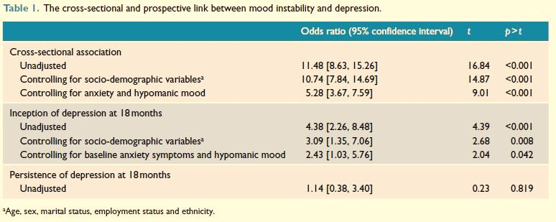

|  |  |  |
| --- | --- | --- |
| Q.8. Which of the following statements is true: (2 marks) | Answer: |  |

1. Anxiety and hypomanic mood at baseline does not affect depression at 18 months
2. At 18 months all depression is predicted by Mood Instability
3. Employment status and alcohol problems are important confounding factors
4. Persistent depression is confounded by employment status
5. Mood Instability significantly predicts new onset depression at 18 months
6. New onset depression is not affected by marital status

|  |  |  |
| --- | --- | --- |
| Q.9. Which following statement is not true about confidence   intervals: (2 marks) | Answer: |  |

1. A confidence interval is an interval of values computed from sample data that is likely to include the true population value
2. An approximate formula for a 95% confidence interval is sample estimate +/- margin of error
3. A confidence interval between 20% and 40% means that the population proportion lies between 20% and 40%.
4. A 99% confidence interval procedure has a higher probability of producing intervals that will include the population parameter than a 95% confidence interval procedure.

Having regard to the following table, the abstract and your other knowledge, please answer the following questions:

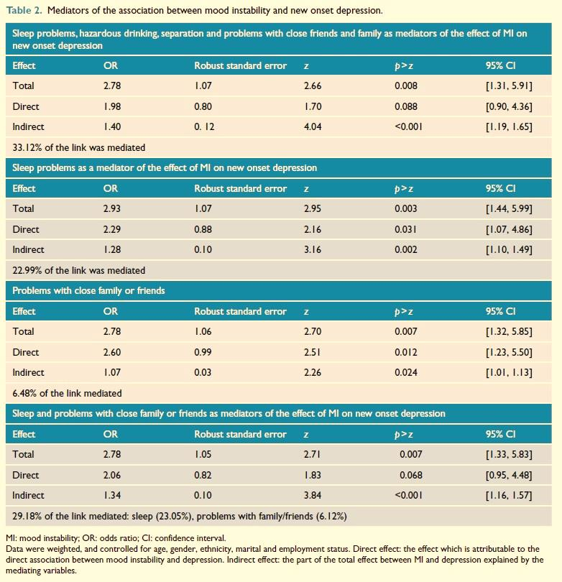

|  |  |  |
| --- | --- | --- |
| Q.10. The pathway from MI to new onset depression is   mediated by: (2 marks) | Answer: |  |

1. Divorce
2. Ethnicity
3. Employment status
4. New onset alcohol problems
5. Poor sleep

|  |  |  |
| --- | --- | --- |
| Q.11. From this study, which of the following is true?   (2 marks) | Answer: |  |

1. Hazardous drinking may cause depression in 33.12% of people with MI
2. Poor sleep and problems with close family or friends cause new onset depression in 29.12% of those with MI
3. Poor sleep and problems with close family or friends explain 29.12% of new episodes of depression in MI
4. Poor sleep and problems with close family or friends mediate 29.12% of the link between MI and a new episode of depression
5. Problems with close family or friends occur in 6.48% of people with MI

**Critical Analysis Question 2 (20 marks)**

*Sodium valproate for the treatment of Tourette's syndrome in children: A systematic review and meta-analysis*

*Chun-Song Yang, Ling-Li Zhang, Yun-Zhu Lin, Qin Guo*

*Department of Pharmacy, Evidence-based Pharmacy Center, West China Second Hospital, Key Laboratory of Birth Defects and Related Diseases of Women and Children, Sichuan University, Chengdu, China*

*Department of Pediatrics, West China Second Hospital, Key Laboratory of Birth Defects and Related Diseases of Women and Children, Sichuan University, Chengdu, China.*

*Available online 2 October 2014*

*Keywords:*

*Sodium valproate, Tourette's syndrome, Children, systematic review*

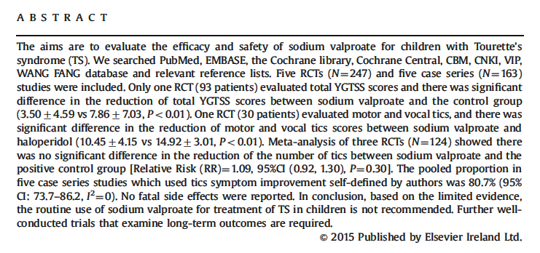

*Abstract:*

*Introduction (excerpt):*

*Excerpt: Introduction*

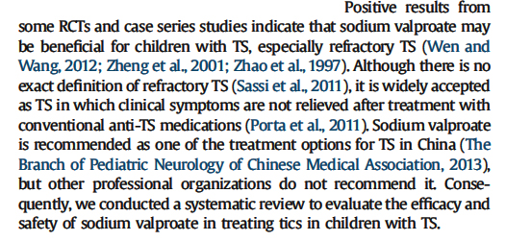

Having regard to the abstract and extract above and your other knowledge, please answer the following questions:

|  |  |  |
| --- | --- | --- |
| Q.1. The rationale for this review was to: (2 marks) | Answer: |  |

1. Add sodium valproate to the practice guidelines for TS
2. Evaluate the effectiveness of sodium valproate in treating tics in children with TS
3. Evaluate the efficacy and safety of sodium valproate in treating tics in children
4. Evaluate the efficacy and safety of sodium valproate in treating tics in children with TS
5. Evaluate the efficacy and safety of sodium valproate in treating tics in TS
6. Review the existing data on the use of sodium valproate in children

|  |  |  |
| --- | --- | --- |
| Q.2. This systematic review is best described as a critical   analysis of: (2 marks) | Answer: |  |

1. All available literature on a specific topic
2. All available research studies on a specific topic
3. All validation studies
4. Current clinical guidelines

|  |  |  |
| --- | --- | --- |
| Q.3. A systematic review differs from a literature review in   which one of the following ways: (2 marks) | Answer: |  |

1. Eligibility criteria are developed based on population and outcomes of interest, and comparisons
2. Eligibility criteria are developed based on population and outcome of interest, and intervention
3. It includes relevant articles published about studies found by a database search
4. It includes relevant randomised controlled trials from high impact journals only
5. It includes relevant published and unpublished studies, papers and reports

*Selection of studies and data extraction:*

*Two reviewers (Yang and Zhang) independently screened the titles and abstracts of every record. Full articles were obtained when either information given in the title or abstracts conformed to the selection criteria outlined previously, or could not be ascertained due to limited information. To include studies, data were extracted independently by each reviewer and entered into a standardized form. Discrepancies were resolved by consensus.*

Having regard to the abstract, the statement above and your other knowledge please answer the following questions:

|  |  |  |
| --- | --- | --- |
| Q.4. The decision about which literature to include involved   checking the studies: (2 Marks) | Answer: |  |

1. Against specific exclusion criteria
2. Against specific inclusion and exclusion criteria
3. By the journal of publication
4. By the reviewers reading the extracts

|  |  |  |
| --- | --- | --- |
| Q.5. In assessing the methodological quality of the studies   being reviewed, one of the factors examined is the   method used to select and allocate subjects to groups.   This is to identify if there is a possibility of: (2 marks) | Answer: |  |

1. Attrition bias
2. Detection bias
3. Performance bias
4. Systematic bias

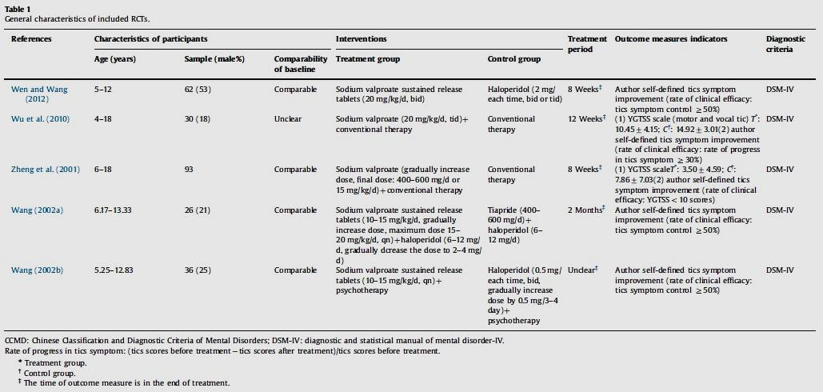

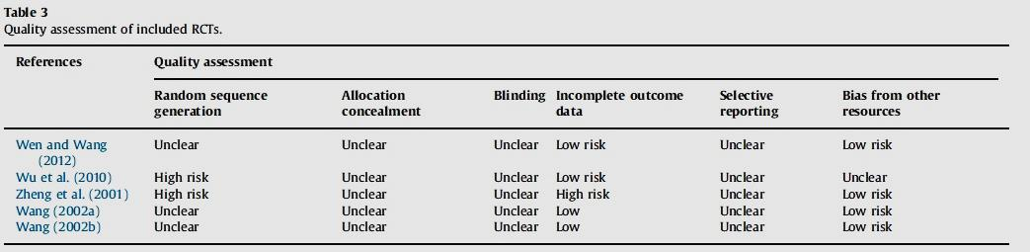

*(Prior extract repeated)*

*Selection of studies and data extraction:*

*Two reviewers (Yang and Zhang) independently screened the titles and abstracts of every record. Full articles were obtained when either information given in the title or abstracts conformed to the selection criteria outlined previously, or could not be ascertained due to limited information. To include studies, data were extracted independently by each reviewer and entered into a standardized form. Discrepancies were resolved by consensus.*

Having regard to Table I and 3 above, the extract above and your other knowledge, in the following questions, which statement is true:

|  |  |  |
| --- | --- | --- |
| Q.6. The included RCTs: (2 marks) | Answer: |  |

1. All recorded follow-up data
2. Contained a total of 117 males
3. Included typical antipsychotics in the comparison group
4. Represent 50% of the studies included
5. Used quasi-randomisation

|  |  |  |
| --- | --- | --- |
| Q.7. The quality assessment revealed: (2 marks) | Answer: |  |

1. 60% of trials used an inadequate method of random sequence generation
2. All trials reported successful blinding
3. Not using ITT analysis may lead to incomplete outcome data
4. Three trials reported loss to follow-up

Figure 2

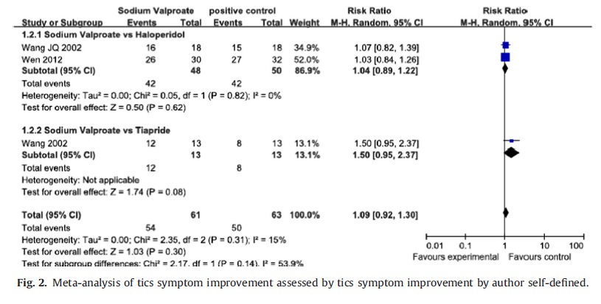

|  |
| --- |
| Having regard to the above figure, the abstract and any other knowledge, select the correct answer from the list below for each of the following questions: (1 mark each) |

1. Confidence Intervals
2. Chi2
3. Degrees of Freedom
4. Forest Plot
5. Funnel Plot
6. Galbraith Plot
7. No difference in risk between groups
8. Radial Plot
9. Risk Ratio
10. Tau
11. Z

|  |  |  |
| --- | --- | --- |
| Q.8. The correct name for the plot in Figure 2 | Answer: |  |

|  |  |  |
| --- | --- | --- |
| Q.9. The number of independent values or quantities which   can be assigned to a statistical distribution | Answer: |  |

|  |  |  |
| --- | --- | --- |
| Q.10. A non parametric test | Answer: |  |

|  |  |  |
| --- | --- | --- |
| Q.11. An estimate of the between-study variance | Answer: |  |

|  |  |  |
| --- | --- | --- |
| Q.12. Which of the following is a valid conclusion from   this study: (2 marks) | Answer: |  |

Sodium valproate:

1. Can only be used for the treatment of TS in Chinese children
2. Has the same outcome in children as other treatments for TS
3. Should be used with caution for the treatment of TS in children
4. Should not be used routinely for the treatment of TS in children
5. Should only be reserved for the treatment of refractory TS in children